
Dashboard Design

Date | 21-September-2026
Team ID | MCA
Project Name | Smartphone Usage, Digital Addiction & Well-Being Analytics
Maximum Marks | 5 Marks

Creating an effective dashboard involves thoughtful design to ensure that the presented information is clear, relevant, and easily understandable for the intended audience. Here are some key principles and best practices for dashboard design
Activity 1: Interactive and visually appealing dashboards
Creating interactive and visually appealing dashboards involves a combination of thoughtful design, effective use of visual elements, and the incorporation of interactive features.
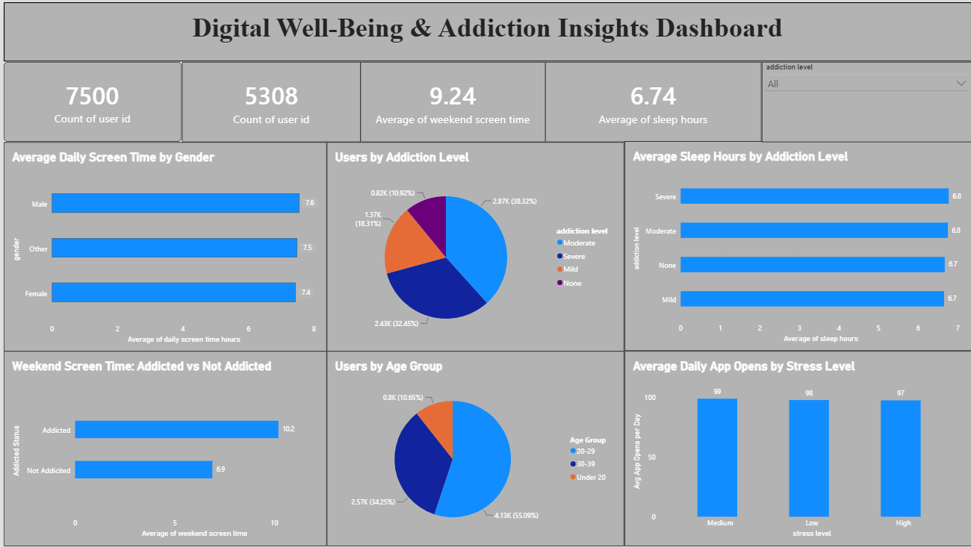
Here are some potential outcomes from the dashboard image provided:
- Total Users Analyzed: The dashboard covers a total of 7,500 users, indicating the scale of the study.

- Addiction Prevalence: 5,308 users are marked as addicted, representing 70.8% of the total user base and highlighting a widespread pattern.
- Weekend Screen Time Gap: The bar chart shows addicted users average 10.2 hours of weekend screen time, compared to just 6.9 hours for non-addicted users, revealing a clear behavioral divide.

- Addiction Level Distribution: The pie chart indicates that Moderate addiction is the most common category (38.32%, 2.87K users), followed by Severe (32.45%, 2.43K), Mild (18.31%, 1.37K), and None (10.92%, 0.82K).

- Age Group Concentration: The pie chart reveals that users aged 20-29 make up over half the population (55.09%, 4.13K users), followed by 30-39 (34.25%) and Under 20 (10.65%), showing addiction risk is concentrated in young adults.

- Screen Time by Gender: The bar chart shows Male users have the highest average daily screen time (7.6 hours), followed closely by Other (7.5 hours) and Female (7.4 hours), indicating minimal variation across genders.

- Sleep Hours by Addiction Level: The bar chart reveals average sleep hours stay nearly constant across all addiction levels (6.7-6.8 hours), suggesting sleep is not a strong differentiator of addiction status.

- App Opens by Stress Level: The column chart shows average daily app opens are highest under Medium stress (99), followed by Low (98) and High stress (97), showing little meaningful variation across stress levels.

- Interactive Filtering: The dashboard includes an addiction level slicer, allowing users to filter all visuals dynamically by Moderate, Severe, Mild, or None for focused analysis.

- Overall Well-Being Snapshot: With an average of 9.24 hours of weekend screen time and 6.74 hours of average sleep, the dashboard highlights a population with high screen exposure and below-recommended rest levels.

